
Patient Participation Group Meeting
Time & Location: Wednesday 19th March 2025 19:00 George Clare Surgery
Present from the Practice: Dr Kim Gabbitas & Melissa Morley (Practice Manager)
PPG Attendees: Ron Hodson, Jeremy Langley, Ted Croucher, Richard Angood & Mike Quinn (Chair)
Minutes
- Practice staffing and organisation update – staff churn/vacancies/new starters

- Two new receptionists are due to start next week which will bring the receptionist team up to full strength.
- An additional Nurse Practitioner has been recruited to join the team and provide general cover as well as specialist treatment for asthma related illnesses.
- Dr Turner is still on sick leave. The practice is using locum GP services to provide cover during his absence so there is no loss of capacity.
- There is currently one vacancy for a Health Care Assistant, other than that the surgery is fully staffed.

- Key statistic reporting – including Patient Did Not Attend (DNA) update

- MM provided DNA figures for January and February broken down by type of appointment (cf attached chart). February total at 243 was lower than January’s of 318 but still represents a significant number of missed appointments. MM reiterated that reminders were being sent out to patients to try to minimise non-attendance.
- The meeting discussed which other key statistics would be useful to track the performance of the practice. It was agreed that it would be good if the practice could share a set of figures that would give a wider view of the range of activities carried out each month and measurements such as numbers of incoming calls being received, average wait time for incoming calls, numbers of appointments carried out etc. MM will look at what information can be readily produced and report to the next meeting.
- JL asked if we could discuss some of his own experiences around difficulties contacting the surgery, getting an appointment and obtaining additional medication when required. This triggered a discussion around the reality of how GP surgeries in general operate in today’s primary care setting. The reality is that demand for services from the surgery is likely to constantly exceed demand and to operate safely there must be a point at which the surgery cannot respond to additional demand. In this situation NHS 111 is there to aid patients that need immediate advice, and the 111 service will direct the patient towards the correct course of action. Also, pharmacies are increasingly able to offer patients advice and medication for conditions that do not need a GP’s involvement.
- JL also made a suggestion that the surgery look at establishing a walk-in facility for some conditions such as chest infections that may occur at certain times of the year and could be dealt with efficiently on a walk-in basis. The practice representatives were unsure about how this might work in practice but said they would look at whether it could be implemented in some form.

- Complaints/Compliments/Suggestions received

  - MM explained that most patient correspondence took the form of general feedback rather than formal complaints, compliments or suggestions but that where a formal complaint was made it would be tracked through a standard process. It was agreed that the number of formal complaints received would be reported as part of the key statistic reporting discussed earlier.

- Practice initiatives – any new/revised methods being introduced

- The new Nurse Practitioner will be able to offer specialist support to patients with asthma and other respiratory conditions.

- PPG e-mail and social media accounts review

- It was agreed that emails that had been mis-directed to the PPG e-mail account and then forwarded to the correct clinical address should not be retained in any folders in the PPG account. They will be deleted, and any future mis-directed emails will be forwarded and then immediately deleted.
- MQ pointed out that the PPG Facebook page had not been updated for around two years and was not serving any useful purpose. It was agreed that it should be allowed to remain dormant and the link to it from the George Clare Surgery website be removed.

- National Association for Patient Participation/The Patients Association.org/other PPG liaison – benefits of participation?

- MQ reported that it appeared that our membership of NAPP had expired –
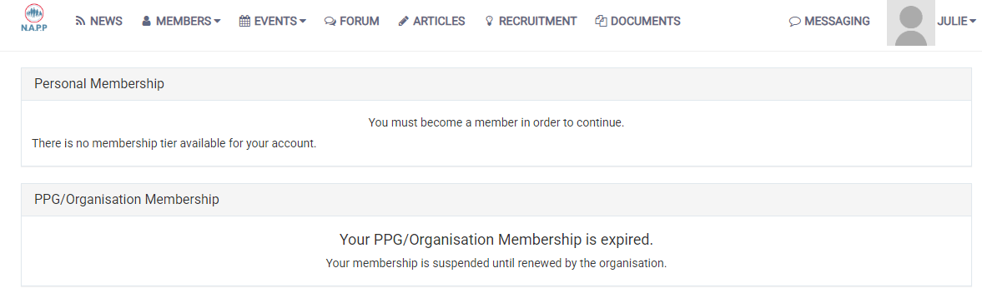
MM said that that shouldn’t be the case as membership had been renewed and the fee paid at the end of February. It is possible that there is confusion around the correct log-in details, which MM undertook to investigate.

- MQ suggested also looking into The Patients Association which is similar to NAPP and appears to offer a range of resources but does not involve payment of any fees. MQ will report back on this at the next meeting.
- MQ also suggested contacting other PPGs in the area with a view to sharing good practice and initiatives. MQ will investigate this and report back.

- Town Council Liaison

- It was agreed that having strong engagement with the Town Council would be mutually productive and so we should renew our effort to encourage their participation in the group and offer to work with them in whichever way they thought best to support the interest of Chatteris residents. MQ will reach out to the Council and report back.

- AOB
- Frequency of future meetings

- It was agreed that every two months was a sensible frequency for meetings

- Date of the next meeting

- Suggested date of next meeting is 28th May
- RH raised an issue around some incidents of items of medication being missing when patients collect their prescriptions and not being informed about when/how the medication would be provided. It was agreed that this shouldn’t happen, and steps would be taken to provide proper communication to patients if there were any issues with supply of their
meds.

- RH pointed out the effect of cancelled routine HCA/Nurse appointments that were being rescheduled three weeks after the original appointment and asked if rescheduled appointments could be arranged without such a long delay. The practice said that each case should be looked at individually as the urgency to reschedule would differ and sometimes it would be acceptable to simply miss a scheduled appointment and skip to the next routine appointment but in other cases an earlier appointment would be needed.

- RA asked if there was likely to be any implications of NHS England being abolished. The answer was given as “no”, it was unlikely to have any impact on the practice.

- RA asked if the GPs are still working to contract or are happy with the new GP contract in general. KG said that working to contract was a matter of working safely and ensuring that other parts of the NHS carried out there responsibilities correctly. The new GP contract seemed to be fit for purpose, but it needs to bed-in.

- The lack of a disabled parking space while contractors work on the Pharmacy building was discussed. MM said that there were no easy options to provide an alternative close enough to the surgery, simply because of the layout of the car park.

- The operation of a night light between the car park and the pharmacy/surgery was raised as there appeared to have been occasions where it had not come on, creating a risk to pedestrians. MM said that this would be referred to an electrician to check.

- MM reported that an order has been placed for supplies of Flu vaccines for use starting in September 2025. There will not be any Covid vaccinations being offered this Spring or Winter at George Clare Surgery at the patients would be advised to contact the local pharmacy or vaccination walk-in location.

